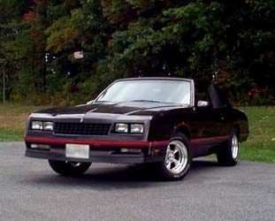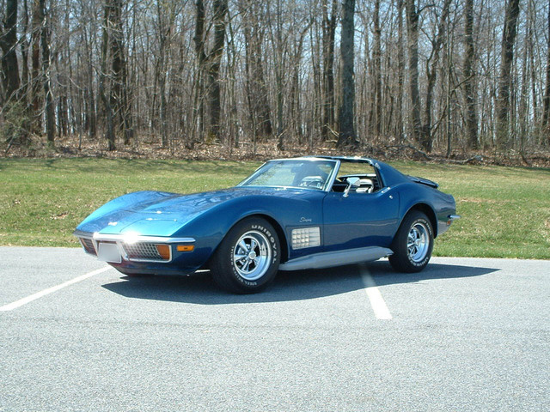

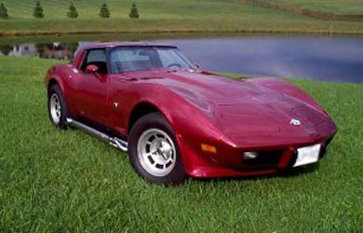

Users have the option to:  - Browse the Discussion Forums.  - Check out pictures of members rides.  - Check out user submitted Downloads  - Find other car related sites from the Web Links.  - Read News and other Topics submitted by Registered Users.  - Read up on upcoming events that can fill all of your car cravings.  - Purchase merchandise from the SweetRides2001.com Store.  - Sign up to unlock all the features of the registered users FREE of charge. | Registered Users have the option to:  - Manage their personal Image Gallery.  - Download or watch Streaming Media of some great car moments.  - Submit a Web Link for everyone else to visit.  - Post on our community message board. Share your thoughts and ideas.  - Signup for: yourname@sweetrides2001.com E-Mail Account and access the SweetRides2001.com Web Mail.  - Upload files and images through the My Uploads Module. Then post those images or files in the Forums, or Downloads for others.

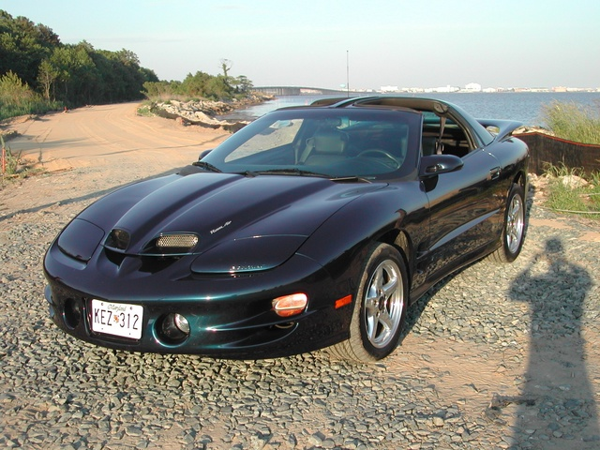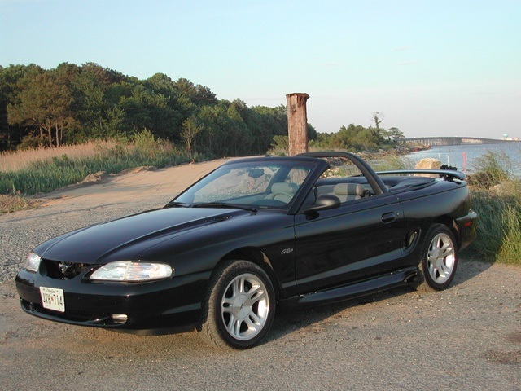

Come join our online car enthusiast community today, and see what the current SweetRides2001 are experiencing.
http://www.SweetRides2001.com

“IT’S YOUR RIDE, IT DESERVES TO BE SHOWN OFF!”
© 2004 www.SweetRides2001.com

